Take Me Out to the

(ESL) Ball Game

An ESL Thematic Unit

Compiled by

Jackie Peters

C:\Program Files\Microsoft Office\MEDIA\CAGCAT10\j0199036.wmf

Take Me Out to the (ESL) Ball Game

ESL Thematic Unit

**Rationale:**

This unit is designed for a mixed beginning and intermediate middle school or high school ESL class. It touches upon many skills areas and culture aspects. Certainly linguistic skills such as vocabulary acquisition, spelling, idioms, verb tenses, etc. are incorporated into the unit and could and should be modified as necessary to suit the needs of each individual student. Culture topics included are history of the game, famous baseball players, geography, food, etc. Here is a simplified layout of the unit:

* Introduction to baseball

Vocabulary of stadiums, rules of the game, geography of the U.S., TPR, writing skills, attentive watching, large and small group work

* *Casey at the Bat*

Various types and levels of questioning, TPR, group communication skills, oral sequencing, prioritizing, character analysis, modified baseball statistical analysis,

Vocabulary, self-reflection/analysis, fine motor skills/drawing

* *Take Me Out to the Ball Game*

Listening skills, verbal anticipation, American cultural aspects, class discussions/oral work, character and cultural analyses

* Technology

Vocabulary, writing skills, keyboarding, culture, Internet research skills, scanning/reading skills, listening practice, prioritizing, multicultural analysis, time delineation

* Additional activities touching upon other curricular areas:
  + Math
  + Science/physics
  + Music
  + Art
  + Physical Education
  + History/geography



* + Community Connections:
  + Writing letters to famous minority players asking them about their experiences
  + Trip to a Minor League (Blue Claws) game or possible a Major League game
  + Enrichment:
  + Movie report on a baseball movie such as:

*The Natural*

*The Lou Gehrig Story*

*A Field of Dreams*

*The Life of Babe Ruth*

Ken Burns’ documentary on baseball

* Book report on a baseball-themed book such as:

*The Southpaw*

*Play for a Kingdom*

*If I Never Get Back*

*Bang the Drum Slowly*

*The Celebrant*

*Willie Mays: The Life, the Legend*

*The Last Boy: Mickey Mantle and the End of America’s Childhood*

*Beyond Belief: Finding the Strength to Come Back*

*The Last Hero: The Life of Hank Aaron*

*Luckiest Man: The Life and Death of Lou Gehrig*

*Clemente: The Passion and Grace of Baseball’s Last Hero*

*Joe DiMaggio: The Hero’s Life*

*Heroes of the Negro League*

*I Never Had it Made: the Autobiography of Jackie Robinson*

*Big Papi: My Story of Big Dreams and Big Hits*

C:\Users\Jackie\AppData\Local\Microsoft\Windows\Temporary Internet Files\Content.IE5\EQ2U7M3B\MC900239527[1].wmf

Take Me Out to the (ESL) Ball Game

Lesson: Initial Baseball Vocabulary and Simple Rules of the Game

*Previous materials this lesson builds upon*:

This initial lesson on baseball terminology and rules will build upon previous knowledge gained from lessons from gym class or material studied on other sports, and general cultural knowledge readily acquired from mass media.

*Overall objectives:*

SWBAT

* talk about baseball
* explain how the game is played
* ask for information
* respond to questions about baseball
* express likes/dislikes
* demonstrate an understanding of the relationship between baseball practices and perspectives as part of American culture

*Materials needed:*

Vocabulary handouts, flashcards

*Activity*:

Students as a whole class/group will listen to the basic rules of the game and the jobs of each of the players on the team. The teacher will ask students about what they have heard and ask for someone to summarize the rules.

*Closing Activity:*

As a whole class/group, the students will participate in a 5-minute closing review activity. Colored flashcards will be presented to the students (written on them will be the field positions for the game). Students will take turns telling the job of each player on the team. Then they will tape the flashcards onto the board in the correct position on the playing diamond. Everyone must tape at least one flashcard on the board before they leave for the day.

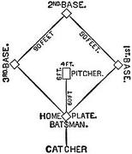[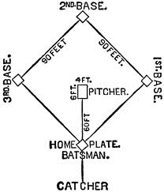](http://www.google.com/imgres?imgurl=http://etc.usf.edu/clipart/14900/14937/bbdiamond_14937_lg.gif&imgrefurl=http://etc.usf.edu/clipart/14900/14937/bbdiamond_14937.htm&usg=__cR9aJ-xcRXMbXLIy1Fr9oXEOcAM=&h=700&w=599&sz=22&hl=en&start=0&zoom=1&tbnid=ZUdOs-NlNTH8oM:&tbnh=131&tbnw=112&prev=/images?q=clipart+baseball+diamond&hl=en&biw=1552&bih=951&gbv=2&tbs=isch:1&itbs=1&iact=hc&vpx=1017&vpy=154&dur=842&hovh=243&hovw=208&tx=116&ty=131&ei=WpgXTdXDG8Oclgfzsq2pBQ&oei=WpgXTdXDG8Oclgfzsq2pBQ&esq=1&page=1&ndsp=43&ved=1t:429,r:6,s:0)

C:\Users\Jackie\AppData\Local\Microsoft\Windows\Temporary Internet Files\Content.IE5\EQ2U7M3B\MC900252613[1].wmf



**Basic Rules of Baseball**

**Taken directly from:** [**http://baseball.about.com/od/thebasics/a/basebasicrules.htm**](http://baseball.about.com/od/thebasics/a/basebasicrules.htm)

**The Game**

A baseball/softball game is played by two teams who alternate between offense and defense. There are nine players on each side. The goal is to score more runs than the opponent, which is achieved by one circuit of four bases that are placed on the diamond.

**The Equipment**

The defense wears baseball/softball gloves, a leather contraption that fits on the hand, to catch the ball. A baseball is a white ball roughly three inches in diameter with red stitching. A softball is roughly twice as big, sometimes yellow (but no softer).

The offense uses a bat, which is made of wood in the professional ranks, and likely made of aluminum or a metal composite at amateur levels. Almost all softball bats are aluminum or metal.

**The Field**

The part of the field closest to the bases is called the infield, and the grassy farther reaches is called the outfield.

The bases are 90 feet apart on the diamond, closer in children's leagues and softball. Other fields are variable, and the outfield fences or the amount of “foul territory” - the amount of ground that borders the field between the long white lines that connect first base to home plate and third base to home plate – varies from field to field.

**Defense: The Positions**

There's a pitcher in the middle of the mound who initiates the action by throwing the ball toward home plate. The catcher catches the ball if it's not hit. The infielders are the first baseman, second baseman, shortstop (between second and third base) and the third baseman. There are three outfielders: The left fielder, center fielder and right fielder.

**The Game**

There are nine innings in professional baseball games (sometimes fewer in lower levels), and each inning is divided in half to the top of the inning (when the visiting team hits and the home team plays defense) and the bottom of the inning (when the home team hits and the visiting team plays defense).

Each team gets three outs in each half of the innings.

**On Offense**

Each team has nine players in its batting order, and they must stick to that order throughout the game (players may substitute in for other players). A play begins with a batter waiting to hit a pitch from the pitcher. If the batter hits the ball into the field of play, the batter runs to first base and can run to as many bases as he or she deems fit without getting "out."

A batter gets three strikes (a swing and a miss or a ball over the plate in what's deemed the “strike zone” by an umpire) or he or she is out. If there are four balls (a pitch that is not in the “strike zone”), the batter is automatically allowed to go to first base.

When a batter begins running, he or she is then referred to as a "runner". Runners attempt to reach a base, where they are "safe" and can remain on the base until the next hitter comes up. The defensive players attempt to prevent this by putting the runners out using the ball; runners put out must leave the field.

A batter gets a "hit" when he or she reaches a base without getting out, or forcing another runner to get out (and without the defense making an error). Runs are scored when a player completes a circuit of the diamond before there are three outs in the inning.

If a players hits the ball over the outfield fence in fair territory (between the foul lines), it's a home run, and the batter can circle all four bases.

**On Defense**

There are many ways that the team on defense can get an offensive player out. Four common ways are:

* Strikeouts (hitter misses three pitches)
* Force outs (when, after the ball is hit, the defensive player with the ball reaches a base before the runner)
* Fly outs (when a player hits the ball in the air and it's caught by a defensive player before the ball hits the ground)
* Tag outs (when a runner is touched with the ball, or a glove with the ball in it)

C:\Users\Jackie\AppData\Local\Microsoft\Windows\Temporary Internet Files\Content.IE5\QKNSFUSC\MC900301478[1].wmf

[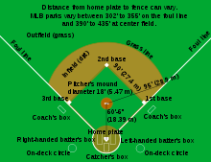](http://en.wikipedia.org/wiki/File:Baseball_diamond.svg)

**In the Ball Park:**

**Use the numbers and letters to label the parts of the baseball field.**

[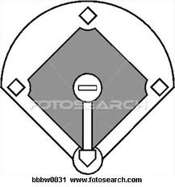](http://www.google.com/imgres?imgurl=http://comps.fotosearch.com/comp/SUE/SUE102/baseball-diamond-overhead_~BBBW0031.jpg&imgrefurl=http://www.fotosearch.com/SUE102/bbbw0031/&usg=__ozu4TcLgMY5zXlQMTmK58YJyGhc=&h=320&w=299&sz=22&hl=en&start=0&zoom=1&tbnid=HEWEMvqoKmxJsM:&tbnh=131&tbnw=122&prev=/images?q=clipart+baseball+diamond&hl=en&biw=1552&bih=951&gbv=2&tbs=isch:1&itbs=1&iact=hc&vpx=253&vpy=160&dur=343&hovh=232&hovw=217&tx=122&ty=131&ei=WpgXTdXDG8Oclgfzsq2pBQ&oei=WpgXTdXDG8Oclgfzsq2pBQ&esq=1&page=1&ndsp=43&ved=1t:429,r:1,s:0)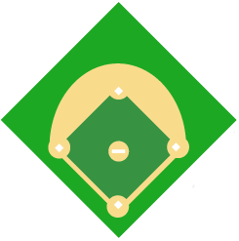

1. First base BB Batter’s box
2. Second base BL Base line
3. Third base HD Home team’s dugout
4. Home plate VD Visitor’s dugout
5. Pitcher’s mound IF Infield
6. Center field OF Outfield

U Umpire FZ Foul zone

**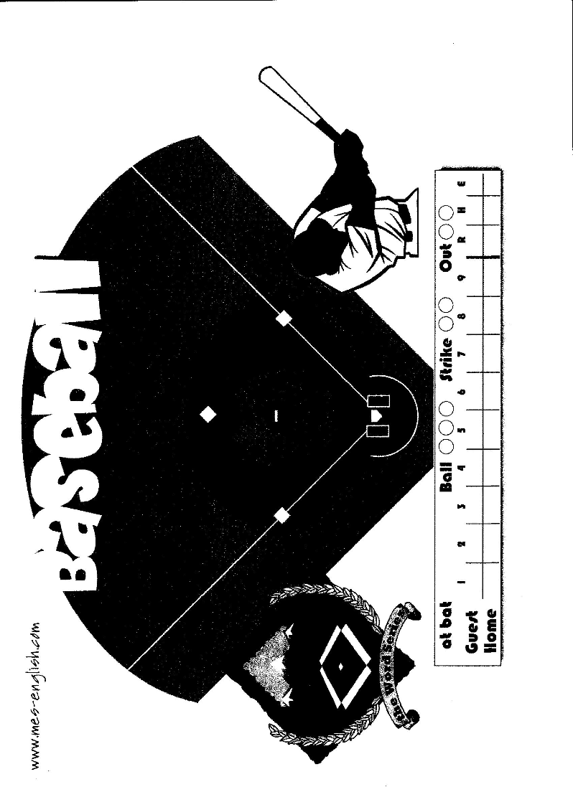**

**Read about Playing the Game:**

Before a baseball game begins, the manager for each team makes a list that shows their team’s *lineup* and *batting order*. A lineup tells which player will play each defensive position. A batting order shows the order in which the players will take their turns to bat.

The team on whose field the game is played is called the *home team.* The other team is the *visiting team.* The visiting team takes the first turn at bat, and the home team takes their positions in the field. The team’s turn to bat last until they make three *outs*. Each time a player advances around the bases during the turn at bat, the team is credited with a *run*. When the visiting team’s turn at bat is over, the home team comes up to bat, and the visitors take the field.

One turn at bat by each team is called an *inning*. A regulation baseball game lasts nine innings. The team with the most runs at the end of the game wins. If the two teams have the same number of runs after nine innings, they play extra innings until one of them scores more runs than the other in an inning.

Each player who comes to bat during a baseball game tries to reach base and advance around the bases. The pitcher and other players of the team in the field try to put each batter out. There are many ways in which the players make outs, reach base, and advance around the field.

**Questions**:

1. What is the difference between a team’s lineup and its batting order?
2. Which teams are the home team and the visiting team?
3. Explain how long a baseball game runs.
4. How exactly does a team score points to win?

C:\Users\Jackie\AppData\Local\Microsoft\Windows\Temporary Internet Files\Content.IE5\WSC1B7D3\MC900229975[1].wmf

[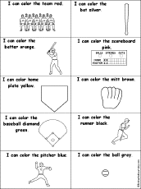](http://www.enchantedlearning.com/colors/icancolor/)

I can color baseball words!

[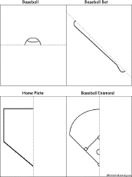](http://www.enchantedlearning.com/finishdrawings/symmetry/)

Finish the drawing

Take Me Out to the (ESL) Ball Game

Lesson: Additional Practice with Baseball Vocabulary

*Previous materials this lesson builds upon*:

This lesson builds on the initial vocabulary lesson on baseball terminology and rules of the game.

*Overall objectives:*

SWBAT

* talk in more detail about baseball
* explain in more detail how the game is played
* ask for information
* ask for and respond to questions about baseball
* express likes/dislikes
* demonstrate an understanding of the relationship between baseball practices and perspectives as part of American culture

*Materials needed:*

Paper plates to serve as “bases,” vocabulary word wall for reference, Internet, LCD, computer

*Do Now:*

To review the new vocabulary before the game, run through the interactive flashcards as a whole class using this site: <http://www.flashcardexchange.com/tag/baseball>

*Activity*:

Students will play a game of classroom baseball (using one of the methods explained in the additional file found on this CD). [Note: this lesson may take 1-2 days.]

*Closing Activity:*

Ask each student to complete a “Leave the Class Ticket” before they can leave.

NA02431_NA02431_NA02431_NA02431_NA02431_NA02431_NA02431_NA02431_NA02431_NA02431_

Things I learned today:

1.

2.

3.

Name: \_\_\_\_\_\_\_\_\_\_\_\_\_\_\_\_\_\_\_\_\_\_

Date: \_\_\_\_\_\_\_\_\_\_\_\_\_\_\_\_\_\_\_\_\_\_

Permission

to leave the class

|  |  |
| --- | --- |
| **The section below was taken from:**  [**http://www.baseball-almanac.com/poetry/po\_case.shtml**](http://www.baseball-almanac.com/poetry/po_case.shtml)  **Casey at the Bat by Ernest Thayer**  It all started in 1885 when George Hearst decided to run for state senator in California. To self-promote his brand of politics, Hearst purchased the San Francisco Examiner. At the completion of the election, Hearst gave the newspaper to his son, William Randolph Hearst.  William, who had experience editing the Harvard Lampoon while at Harvard College, took to California three Lampoon staff members. One of those three was Ernest L. Thayer who signed his humorous Lampoon articles with the pen name Phin.  In the June 3, 1888 issue of The Examiner, Phin appeared as the author of the poem we all know as Casey at the Bat. The poem received very little attention and a few weeks later it was partially republished in the New York Sun, though the author was now known as Anon.  A New Yorker named Archibald Gunter clipped out the poem and saved it as a reference item for a future novel. Weeks later Gunter found another interesting article describing an upcoming performance at the Wallack Theatre by comedian De Wolf Hopper - who was also his personal friend. The August 1888 show (exact date is unknown) had members from the New York and Chicago ball clubs in the audience and the clipping now had a clear and obvious use.  Gunter shared Casey at the Bat with Hopper and the perfomance was nothing short of legendary. Baseball Almanac is pleased to present the single most famous baseball poem ever written. | |
| http://www.baseball-almanac.com/images/spacer.gif   |  |  | | --- | --- | | http://www.baseball-almanac.com/images/typewriter.jpg | "Love has its sonnets galore. War has its epics in heroic verse. Tragedy its sombre story in measured lines. Baseball has Casey at the Bat." - Albert Spalding | | |
| http://www.baseball-almanac.com/images/spacer.gif | |
| |  | | --- | | **Casey at the Bat**  **by Ernest Lawrence Thayer ©** | | **Published: The Examiner (06-03-1888)** | | The Outlook wasn't brilliant for the Mudville nine that day: The score stood four to two, with but one inning more to play. And then when Cooney died at first, and Barrows did the same, A sickly silence fell upon the patrons of the game.  A straggling few got up to go in deep despair. The rest Clung to that hope which springs eternal in the human breast; They thought, if only Casey could get but a whack at that - We'd put up even money, now, with Casey at the bat.  But Flynn preceded Casey, as did also Jimmy Blake, And the former was a lulu and the latter was a cake; So upon that stricken multitude grim melancholy sat, For there seemed but little chance of Casey's getting to the bat.  But Flynn let drive a single, to the wonderment of all, And Blake, the much despis-ed, tore the cover off the ball; And when the dust had lifted, and the men saw what had occurred, There was Jimmy safe at second and Flynn a-hugging third.  Then from 5,000 throats and more there rose a lusty yell; It rumbled through the valley, it rattled in the dell; It knocked upon the mountain and recoiled upon the flat, For Casey, mighty Casey, was advancing to the bat.  There was ease in Casey's manner as he stepped into his place; There was pride in Casey's bearing and a smile on Casey's face. And when, responding to the cheers, he lightly doffed his hat, No stranger in the crowd could doubt 'twas Casey at the bat.  Ten thousand eyes were on him as he rubbed his hands with dirt; Five thousand tongues applauded when he wiped them on his shirt. Then while the writhing pitcher ground the ball into his hip, Defiance gleamed in Casey's eye, a sneer curled Casey's lip.  And now the leather-covered sphere came hurtling through the air, And Casey stood a-watching it in haughty grandeur there. Close by the sturdy batsman the ball unheeded sped- "That ain't my style," said Casey. "Strike one," the umpire said.  From the benches, black with people, there went up a muffled roar, Like the beating of the storm-waves on a stern and distant shore. "Kill him! Kill the umpire!" shouted someone on the stand; And its likely they'd a-killed him had not Casey raised his hand.  With a smile of Christian charity great Casey's visage shone; He stilled the rising tumult; he bade the game go on; He signaled to the pitcher, and once more the spheroid flew; But Casey still ignored it, and the umpire said, "Strike two."  "Fraud!" cried the maddened thousands, and echo answered fraud; But one scornful look from Casey and the audience was awed. They saw his face grow stern and cold, they saw his muscles strain, And they knew that Casey wouldn't let that ball go by again.  The sneer is gone from Casey's lip, his teeth are clenched in hate; He pounds with cruel violence his bat upon the plate. And now the pitcher holds the ball, and now he lets it go, And now the air is shattered by the force of Casey's blow.  Oh, somewhere in this favored land the sun is shining bright; The band is playing somewhere, and somewhere hearts are light, And somewhere men are laughing, and somewhere children shout; But there is no joy in Mudville - mighty Casey has struck out.  "Phin" | | **Casey at the Bat by Ernest Lawrence Thayer ©** |   http://www.baseball-almanac.com/images/spacer.gif | |
| |  | | --- | |  |   http://www.baseball-almanac.com/images/spacer.gif |  |
|  |  |

The "audio moment" below is the actual voice of De Wolf Hopper and you will hear some slight variations in his delivery.

[](http://www.baseball-almanac.com/audio/casey.ram)

Click the Radio to Hear De Wolf Hopper Perform Casey at the Bat

When William De Wolf Hopper performed the poem at Wallack's Theatre, on Broadway and 30th Street in New York City, players from the New York Giants and Chicago White Stockings were guests in the auditorium.

Ernest Lawrence Thayer actually wrote three versions of Casey at the Bat — the first printing, a self-corrupted version, and the revised version.

Take Me Out to the (ESL) Ball Game

Lesson: Listening/reading: *Casey at the Bat*

*Previous materials this lesson builds upon*:

This lesson builds on the vocabulary lessons on baseball terminology and rules of the game.

*Do Now:*

For a fun start to the day as well as for and subsequent discussion, allow a few minutes to watch this famous Bugs Bunny cartoon. Ask students what they like about it, what’s funny about it, etc. <http://www.youtube.com/watch?v=cMfQCL2H5QI&feature=related>

*Overall objectives:*

SWBAT

* listen with understanding
* interact with each other using spoken English for personal expression
* use English to obtain, process, construct, and provide subject matter information in spoken and written form
* use appropriate learning strategies to extend their sociolinguistic and socio-cultural competence
* demonstrate an understanding of the relationship between baseball practices and perspectives as part of American culture

*Materials needed:*

TPR poster, Internet, computer OR CD of the song

*Activity*:

Start with a Gouin series of how to play baseball. Then play the poem and ask comprehension questions about it (use Handout 1, following). Play the poem a few times. Then play the video of the cartoon, “Casey at the Bat” found at: <http://www.youtube.com/watch?v=O2F0qC1-sa0>

*Closing Activity:*

Students will all do one final run-through of the TPR of the Gouin Sequence.

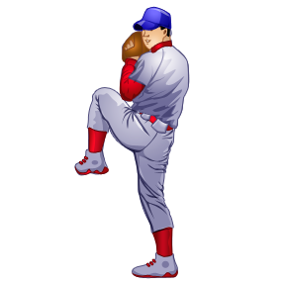

Gouin Sequence

1. Teacher presents series to the class orally, accompanying words with pantomime, props.
2. Teacher repeats series orally and class joins in with pantomime, not with words.
3. Class pantomimes series as teacher repeats orally but does not model actions.
4. Individuals pantomime the series as teacher repeats orally.
5. Class imitates series orally as well as physically, first together and then as individual volunteers.

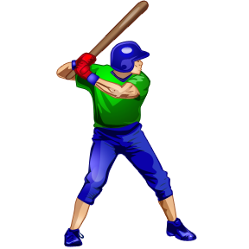

Possible sequence of actions:

I step up to bat.

The pitcher throws the ball.

I hit a home run!

I run the bases.

I score a run!

[The next few sections are taken directly from: 

<http://www.vate.org/pdf/ideas/CaseyattheBat_mar08.pdf>]

**Title of Lesson: Casey at the Bat: An American Hero?**

**Teacher’s Name:** Linda MacCleave

**School:** Retired--Brookland Middle School/Henrico County Public Schools

**Grade Level:** 8

**SOLs Addressed**

• 8.5 The student will read and analyze a variety of narrative and poetic forms.

• 8.6 The student will read, comprehend, and analyze a variety of informational sources.

• 8.7 The student will write in a variety of forms, including narrative, expository,

persuasive, and informational.

**Primary Objectives**

• Students will research and learn about baseball in the American culture.

• Students will increase knowledge of literary techniques and terms.

• Students will increase vocabulary.

• Students will examine the meaning of the hero in literature.

• Students will write about the hero in literature.

• Students will learn about the author Ernest Lawrence Thayer.

**Materials**

• Poem: “Casey at the Bat” by Ernest Lawrence Thayer

(http://www.cosmicbaseball.com/catb\_1.html)

• Computers with Internet access

• Powerpoint: Poetry Terms Using *Casey at the Bat* (included)

• Handouts (attached)

**Focus and Review**

Students will research and learn about baseball in the American culture and read a famous poem

about baseball. Students will increase their knowledge of literary and poetic techniques and learn

about the author and origination of the poem.

**Activities/Procedures**

**Before Reading**

• Students will read about baseball as an American pastime using selected Internet sites.

o Baseball Almanac

o http://www.baseball-almanac.com/

o A Brief History of Baseball: Part II: Professional Baseball's First Hundred Years

o http://www.baseball1.com/bb-data/e-hist-2.html

o Hall of Fame

o http://www.baseballhalloffame.org/

• Directions for students: Write 10 questions based on the information on those 3 sites.

Write Name, Date, and Class at the top of the file followed by Questions by and your

name. Trade seats with someone to answer that student’s questions on his or her

computer while that person answers yours.

• Students will write definitions of the following literary terms: *rhythm, rhyme, rhyme*

*scheme, meter, couplet, onomatopoeia, alliteration, assonance, diction, hero, tragic flaw,*

*narrative poem, parody.*

Reference site: http://owl.english.purdue.edu/handouts/general/gl\_litterms.html

• Students will write definitions of vocabulary words: *patron, multitude, melancholy, doff,*

*writhe, defiance, haughty, grandeur, unheeded, visage, tumult, bade*.

Reference site: <http://www.wordcentral.com/>

**During Reading**

• Students will examine the first stanza to examine its rhythm, rhyme scheme, and meter

• Teacher will introduce the term *iambic heptameter* and other terms in a PowerPoint

presentation: “Casey at the Bat” Introduction (included).

• Students will read the poem aloud, using popcorn method (students choose next reader)

**Activities After Reading**

• Students will answer questions about the poem (Handout 1).

• Students will fill out a graphic organizer to determine if Casey is a hero (Handout 2).

• Discussion Question - Is Casey a hero? (Students may discuss this in small groups or as a

whole.)

• Students will write an essay on whether or not Casey is a hero.

• Students will work in pairs to find examples of some of the literary terms they looked up

prior to reading: *alliteration, assonance, couplet, onomatopoeia, rhyme*

• Students will read about Ernest Lawrence Thayer on web sites

• Suggested sites:

o http://www.sportingnews.com/archives/baseball/94640.html

o http://www.historybuff.com/library/refcasey.html

• Students will answer questions about the author (Handout 3)

• Students will read parodies of this poem and discuss why parodies are written.

o Parody 1: http://www.sportingnews.com/archives/baseball/94785.html

o Parody 2: http://www.baseball-almanac.com/poetry/po\_case7.shtml

• Students can participate in another online activity (optional):

http://www.mcps.k12.md.us/curriculum/socialstd/FT/Casey\_Act.html

• Students can take an online quiz (optional):

<http://www.funtrivia.com/playquiz/quiz79338917ab8.html>

**Assessment**

• Answers to questions about the poem

• Essay on Casey’s status as a hero

• Answers to questions about author

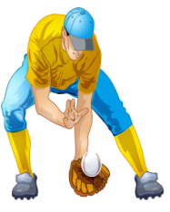

Handout 1 for “Casey at the Bat”

Name:

Date:

**Poem Details**

1. Where does this story take place?
2. What was the score of the game
3. What happened to Coons and Barrows?
4. Why did the crowd think that Casey would not get to bat?
5. What did Flynn and Blake do?
6. How many people were in the stands?
7. Why did the crowd shout “Fraud”?
8. What did Casey do?

C:\Users\Jackie\AppData\Local\Microsoft\Windows\Temporary Internet Files\Content.IE5\WSC1B7D3\MC900330438[1].wmf

Handout 2 for “Casey at the Bat”

Name:

Date:

**Is Casey a Hero?**

|  |  |
| --- | --- |
| Casey’s Heroic Qualities | Casey’s Non-Heroic Qualities |
|  |  |

Handout 3 for “Casey at the Bat”

Name:

Date:

**Ernest Lawrence Thayer and "Casey at the Bat"**

Using the Internet, find answers to these questions about Ernest Lawrence Thayer and the poem, “Casey at the Bat.”

An excellent resource of articles can be found at

<http://www.sportingnews.com/archives/baseball/94640.html>.

1. Where and when did this poem first appear?

2. Who inspired the character of Casey in the poem by Ernest Thayer?

3. According to Leonard Koppett in an article written in 1998, there were 18 lines missing from

the poem. How did those 18 lines change the story? Do you believe Koppett, or do you think he

is making this up? Why?

4. Read the other articles to find out the original complete title and what pseudonym Thayer used.

C:\Users\Jackie\AppData\Local\Microsoft\Windows\Temporary Internet Files\Content.IE5\WDVL49XU\MC900410999[1].wmf

Take Me Out to the (ESL) Ball Game

Lesson: Interview with Casey

*Previous materials this lesson builds upon*:

This lesson builds on the initial listening, reading, and viewing lessons on *Casey at the Bat*.

*Overall objectives:*

SWBAT

* Ask and answer questions
* Take the point of view of a character in a poem
* Write and perform a dialogue based on an interview
* Demonstrate an understanding of the relationship between baseball practices and perspectives as part of American culture

*Materials needed:*

Interview handouts, rubric

*Do Now:*

TPR practice: see list of possible ideas for *Simon Says*-like review.

*Activity*:

Put students in pairs. One student takes the part of the newspaper report, and the other acts as Casey, from the poem, *Casey at the Bat*. When finished with the interview, both students help write the dialogue detailing some of the athlete’s life. Students present their interviews to the class. [Note: This lesson will take 2 – 3 days to complete.]

*Closing Activity*

Fill out the Sequence of Events form as a review of the poem.

TPR Suggestions

Rubbed his hands

Strike one

Strike two

Strike three

Silence

Raised his hand

Smiled

Sneered

Clenched his teeth

Pitched a fast ball

Stepped up to the plate

Out

Struck out

Ran to first base

**Rubric: An Interview with Casey \_\_\_\_ 30**

|  |  |  |  |
| --- | --- | --- | --- |
|  | **Exceeds Expectations**  **5** | **Meets Expectations**  **3** | **Does not meet Expectations**  **1** |
| **How well do I communicate?**  (Text Type and Language Control ) | We create with the language by using strings of sentences and are generally accurate. | We create with language by using simple sentences and some strings of sentences and are occasionally accurate. | We use simple sentences, isolated words, and memorized phrases with accuracy. |
| **What kind of**  **vocabulary do I**  **use?**  (Vocabulary Use) | We use a wide range of vocabulary appropriate to the topic most of the time. | We use a range of vocabulary that accomplishes the task. However, occasionally we may use the wrong word or expression. | We use basic vocabulary and resort to English when we are unable to communicate my message. |
| **How well am I understood?**  (Comprehensibility) | We are generally understood by those unaccustomed to the speaking/writing of language learners. | We are generally understood by those accustomed to the speaking/writing of language learners. | We are understood with occasional difficulty by those accustomed to the speaking/writing of language learners. |
| **How well do I capture and maintain my audience’s attention?**  (Impact) | We make good choices of phrases, images, and content to maintain the attention of the audience. | We make some good choices of phrases, images, and content to maintain the attention of the audience. | We use mostly gestures or visuals to maintain audience’s attention. We use some phrases, but my vocabulary conveys very basic information. |
| **How organized and fluent is my presentation?**  (Communication Strategies) | We organize my presentation in a logical manner. We speak/write with fluency. | We organize my presentation in a logical manner. We pause a few times, disrupting the flow. | We focus mostly on the completion of the task; we pay little attention to the organization and flow of my presentation. |
| **How well do I demonstrate cultural understanding?**  (Cultural Awareness) | We generally demonstrate awareness of cultural appropriateness. | We occasionally demonstrate awareness of cultural appropriateness | We do not demonstrate an awareness of cultural appropriateness. |

An Interview with Casey

Think of **six** questions you would like to ask Casey after the game. Write those questions in the Reporter’s sections on this worksheet. Then think of how Casey would answer those questions and write his responses on the appropriate lines. Add a greeting and a closing statement. Practice your interview and perform it for the class. Remember to make the questions and statements relevant to the poem.

Greeting (Reporter):

\_\_\_\_\_\_\_\_\_\_\_\_\_\_\_\_\_\_\_\_\_\_\_\_\_\_\_\_\_\_\_\_\_\_\_\_\_\_\_\_\_\_\_\_\_\_\_\_

Reporter:

\_\_\_\_\_\_\_\_\_\_\_\_\_\_\_\_\_\_\_\_\_\_\_\_\_\_\_\_\_\_\_\_\_\_\_\_\_\_\_\_\_\_\_\_\_\_\_\_

\_\_\_\_\_\_\_\_\_\_\_\_\_\_\_\_\_\_\_\_\_\_\_\_\_\_\_\_\_\_\_\_\_\_\_\_\_\_\_\_\_\_\_\_\_\_\_\_

Casey:

\_\_\_\_\_\_\_\_\_\_\_\_\_\_\_\_\_\_\_\_\_\_\_\_\_\_\_\_\_\_\_\_\_\_\_\_\_\_\_\_\_\_\_\_\_\_\_\_

\_\_\_\_\_\_\_\_\_\_\_\_\_\_\_\_\_\_\_\_\_\_\_\_\_\_\_\_\_\_\_\_\_\_\_\_\_\_\_\_\_\_\_\_\_\_\_\_

Reporter:

\_\_\_\_\_\_\_\_\_\_\_\_\_\_\_\_\_\_\_\_\_\_\_\_\_\_\_\_\_\_\_\_\_\_\_\_\_\_\_\_\_\_\_\_\_\_\_\_

\_\_\_\_\_\_\_\_\_\_\_\_\_\_\_\_\_\_\_\_\_\_\_\_\_\_\_\_\_\_\_\_\_\_\_\_\_\_\_\_\_\_\_\_\_\_\_\_

Casey:

\_\_\_\_\_\_\_\_\_\_\_\_\_\_\_\_\_\_\_\_\_\_\_\_\_\_\_\_\_\_\_\_\_\_\_\_\_\_\_\_\_\_\_\_\_\_\_\_

\_\_\_\_\_\_\_\_\_\_\_\_\_\_\_\_\_\_\_\_\_\_\_\_\_\_\_\_\_\_\_\_\_\_\_\_\_\_\_\_\_\_\_\_\_\_\_\_

Reporter:

\_\_\_\_\_\_\_\_\_\_\_\_\_\_\_\_\_\_\_\_\_\_\_\_\_\_\_\_\_\_\_\_\_\_\_\_\_\_\_\_\_\_\_\_\_\_\_\_

\_\_\_\_\_\_\_\_\_\_\_\_\_\_\_\_\_\_\_\_\_\_\_\_\_\_\_\_\_\_\_\_\_\_\_\_\_\_\_\_\_\_\_\_\_\_\_\_

Casey:

\_\_\_\_\_\_\_\_\_\_\_\_\_\_\_\_\_\_\_\_\_\_\_\_\_\_\_\_\_\_\_\_\_\_\_\_\_\_\_\_\_\_\_\_\_\_\_\_

\_\_\_\_\_\_\_\_\_\_\_\_\_\_\_\_\_\_\_\_\_\_\_\_\_\_\_\_\_\_\_\_\_\_\_\_\_\_\_\_\_\_\_\_\_\_\_\_

Reporter:

\_\_\_\_\_\_\_\_\_\_\_\_\_\_\_\_\_\_\_\_\_\_\_\_\_\_\_\_\_\_\_\_\_\_\_\_\_\_\_\_\_\_\_\_\_\_\_\_

\_\_\_\_\_\_\_\_\_\_\_\_\_\_\_\_\_\_\_\_\_\_\_\_\_\_\_\_\_\_\_\_\_\_\_\_\_\_\_\_\_\_\_\_\_\_\_\_

Casey:

\_\_\_\_\_\_\_\_\_\_\_\_\_\_\_\_\_\_\_\_\_\_\_\_\_\_\_\_\_\_\_\_\_\_\_\_\_\_\_\_\_\_\_\_\_\_\_\_

\_\_\_\_\_\_\_\_\_\_\_\_\_\_\_\_\_\_\_\_\_\_\_\_\_\_\_\_\_\_\_\_\_\_\_\_\_\_\_\_\_\_\_\_\_\_\_\_

Reporter:

\_\_\_\_\_\_\_\_\_\_\_\_\_\_\_\_\_\_\_\_\_\_\_\_\_\_\_\_\_\_\_\_\_\_\_\_\_\_\_\_\_\_\_\_\_\_\_\_

\_\_\_\_\_\_\_\_\_\_\_\_\_\_\_\_\_\_\_\_\_\_\_\_\_\_\_\_\_\_\_\_\_\_\_\_\_\_\_\_\_\_\_\_\_\_\_\_

Casey:

\_\_\_\_\_\_\_\_\_\_\_\_\_\_\_\_\_\_\_\_\_\_\_\_\_\_\_\_\_\_\_\_\_\_\_\_\_\_\_\_\_\_\_\_\_\_\_\_

\_\_\_\_\_\_\_\_\_\_\_\_\_\_\_\_\_\_\_\_\_\_\_\_\_\_\_\_\_\_\_\_\_\_\_\_\_\_\_\_\_\_\_\_\_\_\_\_

Reporter:

\_\_\_\_\_\_\_\_\_\_\_\_\_\_\_\_\_\_\_\_\_\_\_\_\_\_\_\_\_\_\_\_\_\_\_\_\_\_\_\_\_\_\_\_\_\_\_\_

\_\_\_\_\_\_\_\_\_\_\_\_\_\_\_\_\_\_\_\_\_\_\_\_\_\_\_\_\_\_\_\_\_\_\_\_\_\_\_\_\_\_\_\_\_\_\_\_

Casey:

\_\_\_\_\_\_\_\_\_\_\_\_\_\_\_\_\_\_\_\_\_\_\_\_\_\_\_\_\_\_\_\_\_\_\_\_\_\_\_\_\_\_\_\_\_\_\_\_

\_\_\_\_\_\_\_\_\_\_\_\_\_\_\_\_\_\_\_\_\_\_\_\_\_\_\_\_\_\_\_\_\_\_\_\_\_\_\_\_\_\_\_\_\_\_\_\_

(Closing statement) Reporter:

\_\_\_\_\_\_\_\_\_\_\_\_\_\_\_\_\_\_\_\_\_\_\_\_\_\_\_\_\_\_\_\_\_\_\_\_\_\_\_\_\_\_\_\_\_\_\_\_

\_\_\_\_\_\_\_\_\_\_\_\_\_\_\_\_\_\_\_\_\_\_\_\_\_\_\_\_\_\_\_\_\_\_\_\_\_\_\_\_\_\_\_\_\_\_\_\_



**Audience Evaluation Sheet**

**Name:**

Group #1

What they did great:

Group #2

What they did great:

Group #3

What they did great:

Group #4

What they did great:

Group #5

What they did great:

Group #6

What they did great:

**Name:\_\_\_\_\_\_\_\_\_\_\_\_\_\_\_\_\_\_\_\_\_\_\_\_\_\_\_\_**

**What Happened?**

**Sequence of Events in the Poem**

**At the beginning: Mudville is losing 4 to 2 in the 9th inning**

1st Event:

**↓**

2nd Event:

**↓**

3rd Event:

**↓**

Casey is at bat:

**↓**

Final Event:

Take Me Out to the (ESL) Ball Game

Lesson: Classification of Baseball Cards

*Previous materials this lesson builds upon*:

This lesson builds on the previous listening, reading, and viewing lessons about baseball.

*Overall objectives:*

SWBAT

* Read a variety of materials and texts with comprehension and critical analysis
* Use learning strategies to extend their communicative competence
* Use English to interact in the classroom
* Use appropriate learning strategies to construct and apply academic knowledge
* Draw on background knowledge and apply it in relevant ways
* Demonstrate an understanding of the relationship between baseball practices and perspectives as part of American culture

*Materials needed:*

Baseball cards, classification worksheet, Internet, LCD, computer

*Do Now:*

Show a video about collecting baseball cards and have a little discussion about it afterwards.

A possibility: <http://www.youtube.com/watch?v=rFXTHyqoqgc>

*Activity*:

Explain that classifying is an important skill and that when students are able to group together relevant pieces of information, it can help them have a better understanding of the text they read. It also helps them organize their own writing better. Teacher models classifying technique first using 5 cards. Put students into pairs or small groups and pass out cards and one handout. As teacher modeled, the groups group cards by similar attributes: where the player lives, which team he plays on, which job he has on the team, etc. Students should decide what the classifications are.

*Closing Activity*

Tally on the board how many students have cards with similar features. Talk about similarities and differences between the players.

**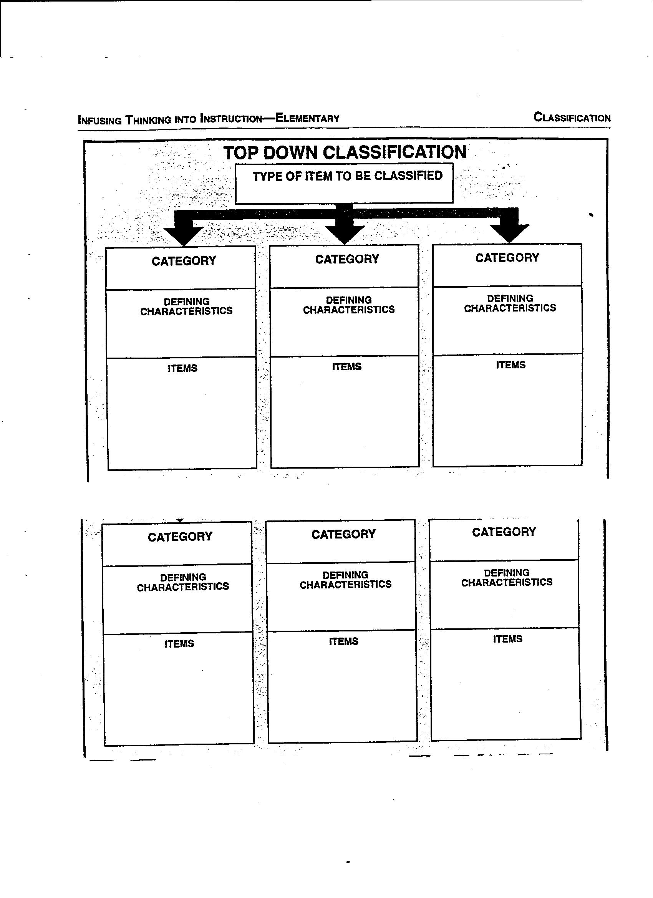**

Take Me Out to the (ESL) Ball Game

Lesson: Listening to a Baseball Song

*Previous materials this lesson builds upon*:

This lesson builds on the previous listening, reading, and viewing lessons about baseball and about the poem, *Casey at the Bat*.

*Overall objectives:*

SWBAT

* Recall facts about the rules of baseball
* Recall facts about the poem
* Listen critically and with understanding
* Fill in words of a song in a Cloze activity
* Discuss cultural aspects of the song in a class discussion
* Express likes/dislikes
* Demonstrate an understanding of the relationship between baseball practices and perspectives as part of American culture

*Materials needed:*

Internet, LCD, computer, handouts

*Do Now:*

Watch this old cartoon and write down what is the funniest part:

<http://www.youtube.com/watch?v=fUjZgOWM3s0>

*Activity*:

Play the song, “Take Me Out to the Ballgame.” Ask students to fill in the missing words using the Cloze handout. Talk about the missing words and play the song a second time if necessary. Show the correct words. Talk about cultural aspects of the song.

*Closing Activity*

Watch the cartoon and compare it to the cartoon shown in the Do Now: write one similarity and one difference on the exit ticket before leaving the classroom.

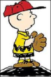NA02431_NA02431_NA02431_NA02431_NA02431_NA02431_NA02431_NA02431_NA02431_NA02431_[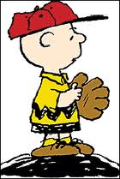](http://www.google.com/imgres?imgurl=http://petcaretips.net/charliebrown_pitchersMound.gif&imgrefurl=http://petcaretips.net/charlie_brown_baseball.html&usg=__PSeJ4ctv1M97zG0ZRtFuUfdT-sE=&h=262&w=175&sz=7&hl=en&start=0&zoom=1&tbnid=C0UhuJKZlcYsoM:&tbnh=146&tbnw=97&prev=/images?q=charlie+brown+baseball&hl=en&sa=G&biw=1552&bih=951&gbv=2&tbs=isch:1&itbs=1&iact=hc&vpx=1349&vpy=110&dur=10&hovh=209&hovw=140&tx=135&ty=120&ei=Ak0ZTdShEIG8lQeO44DPCw&oei=Ak0ZTdShEIG8lQeO44DPCw&esq=1&page=1&ndsp=38&ved=1t:429,r:7,s:0)

Similarity:

1.

DIFFERENCE:

2..

Name: \_\_\_\_\_\_\_\_\_\_\_\_\_\_\_\_\_\_\_\_\_\_

Date: \_\_\_\_\_\_\_\_\_\_\_\_\_\_\_\_\_\_\_\_\_\_

Permission

to leave the class

Take Me Out to the Ballgame

Cloze Activity

Name: \_\_\_\_\_\_\_\_\_\_\_\_\_\_\_\_\_\_\_\_\_\_\_\_\_\_\_\_\_\_\_\_\_\_

Take me out to the ball game, \_\_\_\_\_\_\_\_\_\_\_\_\_\_\_\_ me out

with the \_\_\_\_\_\_\_\_\_\_\_\_\_\_\_\_\_. Buy me some \_\_\_\_\_\_\_\_\_\_\_\_\_\_\_

and Cracker \_\_\_\_\_\_\_\_\_\_\_\_\_\_\_\_\_\_. I don’t \_\_\_\_\_\_\_\_\_\_\_\_\_\_\_\_

if I never \_\_\_\_\_\_\_\_\_\_\_\_\_\_\_\_\_ back. Let me \_\_\_\_\_\_\_\_\_\_\_\_\_\_\_,

root, \_\_\_\_\_\_\_\_\_\_\_\_\_\_ for the \_\_\_\_\_\_\_\_\_\_\_\_\_\_\_\_ team. If they don’t \_\_\_\_\_\_\_\_\_\_\_\_\_\_\_\_\_ it’s a \_\_\_\_\_\_\_\_\_\_\_\_\_\_\_\_\_\_\_\_\_\_\_.

For it’s \_\_\_\_\_\_\_\_\_\_\_\_\_\_\_\_, two, three \_\_\_\_\_\_\_\_\_\_\_\_\_\_\_\_\_\_

you’re \_\_\_\_\_\_\_\_\_\_\_\_\_\_\_\_\_\_ at the old ball \_\_\_\_\_\_\_\_\_\_\_\_\_\_\_.



Cloze Activity

Answers:

Take me out to the ball game, \_\_\_\_take\_\_\_\_\_\_\_\_\_\_\_\_ me out

with the \_\_\_crowd\_\_\_\_\_\_\_\_\_\_\_. Buy me some \_\_peanuts\_\_\_\_\_\_\_\_\_

and Cracker \_\_Jacks\_\_\_\_\_\_\_\_\_. I don’t \_\_\_care\_\_\_\_\_\_\_\_\_\_\_\_\_

if I never \_come\_\_\_\_\_\_\_\_\_\_\_\_\_ back. Let me \_root\_\_\_\_\_\_\_\_\_\_\_,

root, \_\_root\_\_\_\_\_\_\_\_\_ for the \_home\_\_\_\_\_\_\_\_\_\_\_\_ team. If they don’t \_\_win\_\_\_\_\_\_\_\_\_\_\_\_\_\_\_ it’s a \_\_shame\_\_\_\_\_\_\_\_\_\_\_\_\_\_\_\_\_\_.

For it’s \_\_\_\_one\_\_\_\_\_\_\_\_\_, two, three \_\_strikes\_\_\_\_\_\_\_\_\_\_\_\_\_

you’re \_\_\_out\_\_\_\_\_\_\_\_\_\_\_ at the old ball \_\_\_game\_\_\_\_\_\_\_\_\_\_\_\_.

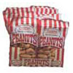

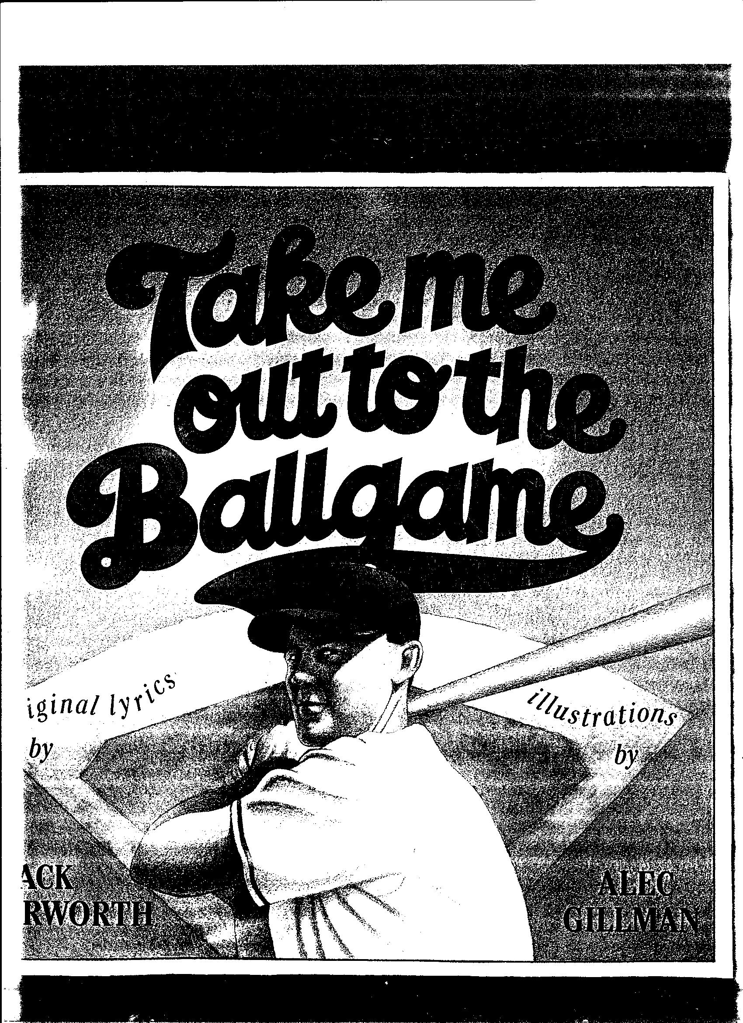

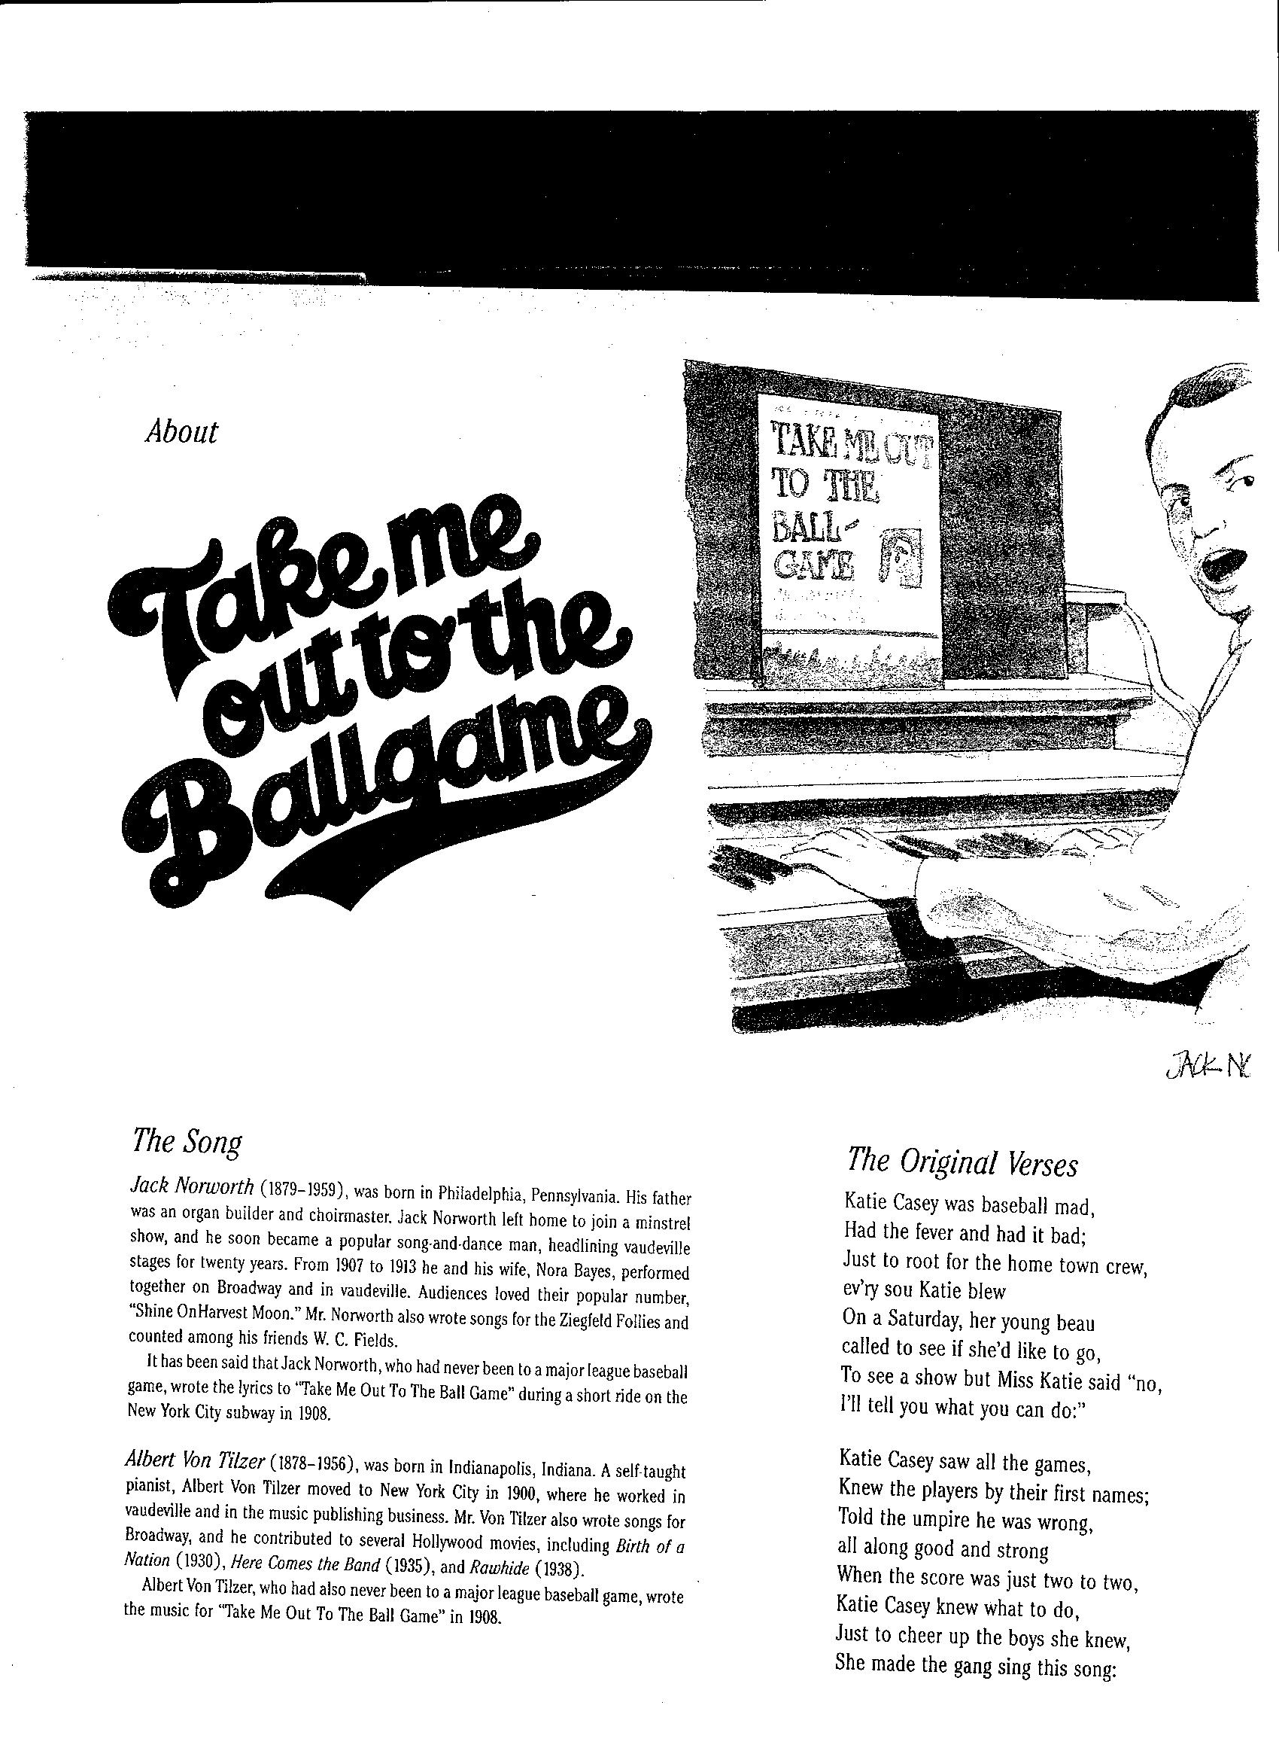

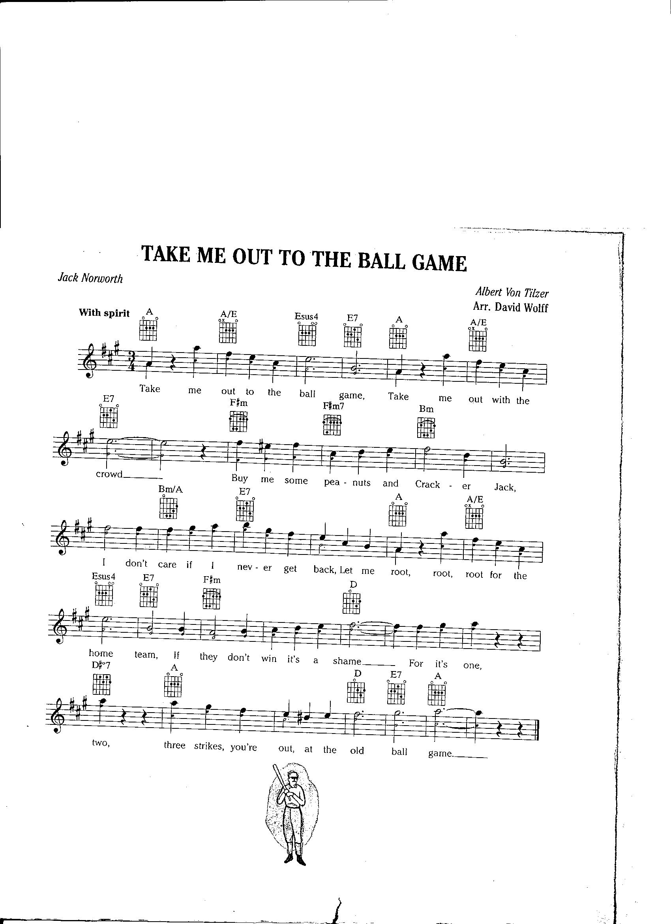[](http://www.google.com/imgres?imgurl=http://petcaretips.net/charliebrown_pitchersMound.gif&imgrefurl=http://petcaretips.net/charlie_brown_baseball.html&usg=__PSeJ4ctv1M97zG0ZRtFuUfdT-sE=&h=262&w=175&sz=7&hl=en&start=0&zoom=1&tbnid=C0UhuJKZlcYsoM:&tbnh=146&tbnw=97&prev=/images?q=charlie+brown+baseball&hl=en&sa=G&biw=1552&bih=951&gbv=2&tbs=isch:1&itbs=1&iact=hc&vpx=1349&vpy=110&dur=10&hovh=209&hovw=140&tx=135&ty=120&ei=Ak0ZTdShEIG8lQeO44DPCw&oei=Ak0ZTdShEIG8lQeO44DPCw&esq=1&page=1&ndsp=38&ved=1t:429,r:7,s:0)